Validation Testing Cases & Screenshots

| Test Case # | Test Case Description | Projected Results | Direct Dependencies |
| --- | --- | --- | --- |
| 1 | Player selects piece | Player selects one of their own pieces to move. | Player has a piece to select. |
| 2 | Player moves piece | Player moves one of their own pieces once selected. | Player has a piece to move. |
| 3 | Players captures opponent’s piece | Player moves a piece to capture an Opponent’s piece. | Player has a piece to move, the Opponent’s piece is in the appropriate space to be captured by the Player. |
| 4 | Player promotes to King | Player’s piece gets promoted to King, acquiring all of the appropriate movesets. | Player’s piece reaches the other side of the board. |
| 5 | System switch turns | Once the Player’s turn is finished, it switches to the Opponent’s turn. | Player has moved a piece. |
| 6 | System checks for valid move | System evaluates if the piece the Player selects can be moved on the space the Player clicks on. | Player has a piece to move. |
| 7 | System checks for win condition | System evaluates if either Player captured all of their Opponent’s pieces. | Either Player eliminates all of the Opponent’s pieces. |

# Test Case 1: Player selects piece (Piece is not highlighted while selected, so if the piece is moved, it was selected.)

This test case works perfectly as intended as Both Players can select one of their own pieces to move when it is their turn. This also applies when playing against Bots as well.

# Test Case 2: Player moves piece

This test case works perfectly as intended as Both Players can move one of their own pieces once selected provided it is on their own turn. This applies to when playing against Bots as well.

# Test Case 3: Players captures opponent’s pieceThis test case works perfectly as intended as the Players can move a piece to capture an Opponent’s piece if they are adjacent to it and no piece is blocking their path (provided it is a valid move). This applies to the Bots as well.

# Test Case 4: Player promotes to King

This test case works perfectly as intended as the regular pieces get promoted to a King when a piece successfully reaches the other side of the Board (pieces with white dots in the middle are King pieces). When playing against Bots, the Bots also are able to promote to King pieces as intended.

# Test Case 5: System switch turns

This test case works perfectly as intended, the System switches turns after each Player on Local Play makes a move. The turn switches instantly when playing against Bots, so it works there as well.

# Test Case 6: System checks for valid move

(Images are marked up for clarity)

This test case works perfectly as intended as the System evaluates if the piece the Player selects can be moved on the space the Player clicks on. Piece is not highlighted while selected, so if the piece moves, it is a valid move. If the piece does not move, it was an invalid move.

# 

# Test Case 7: System checks for win condition

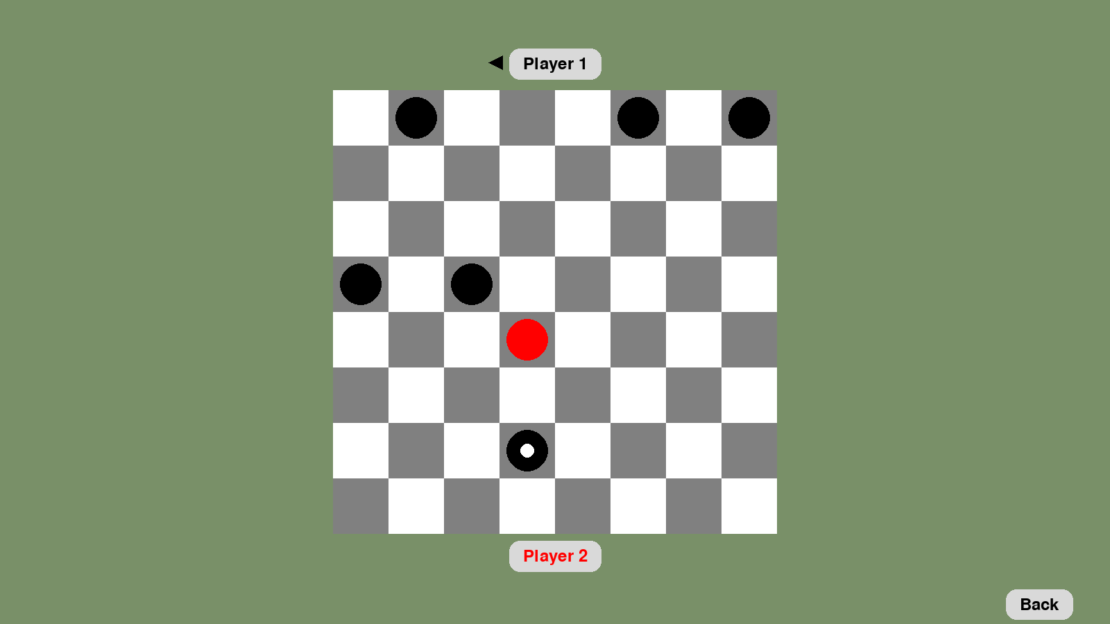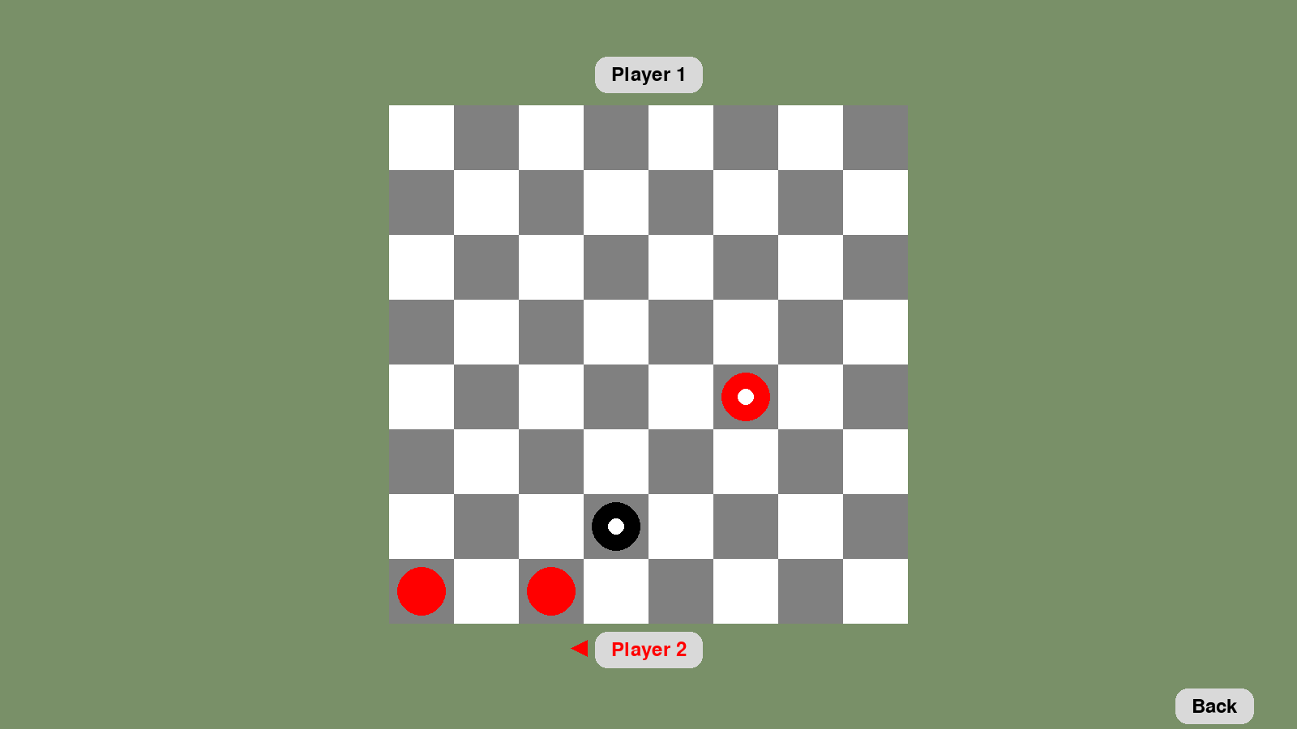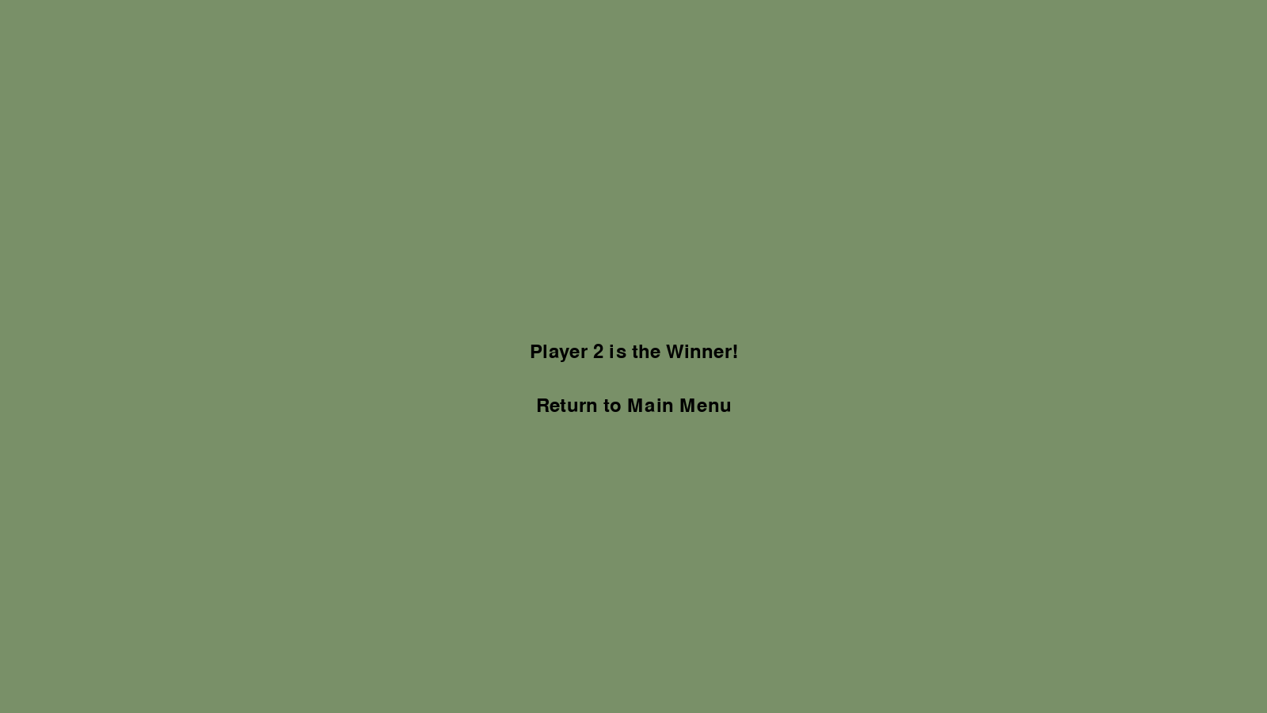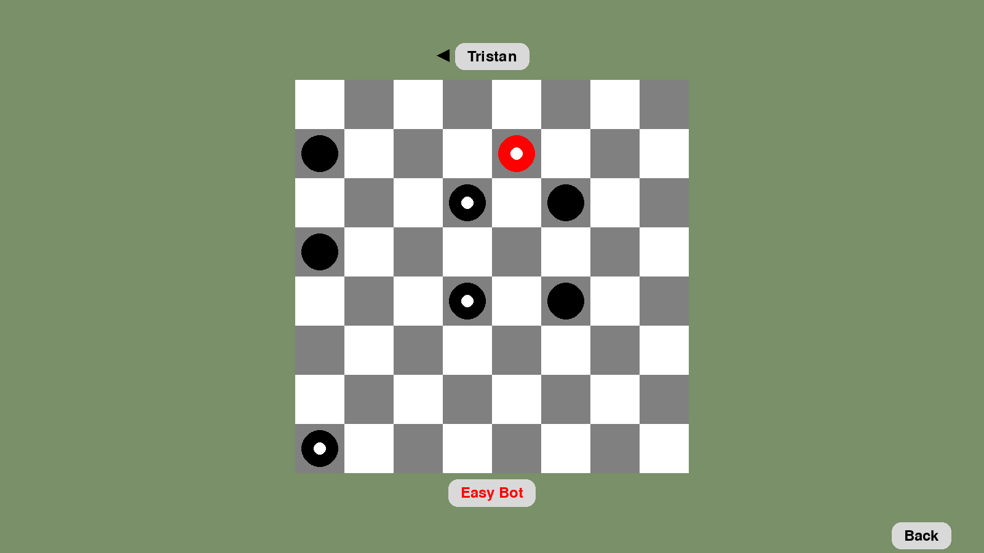

## 

(VS Medium Bot)

## 

(VS Hard Bot)

## 

This Test Case works perfectly as intended, I was able to win as Player 1 and Player 2 on local play as well as being able to win against the Easy bot, Medium Bot, and the Hard Bot. I was also able to lose to the Easy bot, Medium Bot and the Hard Bot (so that they won). The Board also resets after the game is finished.